**DAILY ONLINE ACTIVITIES SUMMARY**

|  |  |  |  |  |  |  |  |
| --- | --- | --- | --- | --- | --- | --- | --- |
| **Date:** | **18-05-2020** | | | | **Name:** | **B.A.SOHANKUMAR** | |
| **Sem & Sec** | **4TH SEM A** | | | | **USN:** | **4AL18CS013** | |
| **Online Test Summary** | | | | | | | |
| **Subject** | | **COMPLEX ANALYSIS, PROBABILITY AND STATISTICAL METHODS** | | | | | |
| **Max. Marks** | | **30** | | **Score** | | **11** | |
| **Certification Course Summary** | | | | | | | |
| **Course** | **GOOGLE ANALYTICS** | | | | | | |
| **Certificate Provider** | | | **GOOGLE** | **Duration** | | | **4 HOURS** |
| **Coding Challenges** | | | | | | | |
| **Problem Statement:To check whether the given strings are Anagram or not.** | | | | | | | |
| **Status:Executed** | | | | | | | |
| **Uploaded the report in Github** | | | | **YES** | | | |
| **If yes Repository name** | | | | **https://github.com/sohannaik5648987/lockdown-coding** | | | |
| **Uploaded the report in slack** | | | | **YES** | | | |

**Online Test Details:**

The online test was from module 4 which was about curve fitting and statistical method. There were 30 questions and the duration was 30 minutes. The score for the test was not displayed after the test.Snap shot was not taken.

**Certification Course Details:**

Course Name:GOOGLE ANALYTICS FOR BEGINNERS

This course contains many video lectures and also 4 assessments where we have to score a minimum of 70% marks in each assessment in order to obtain the certificate.Google Analytics for Beginners shows new users how to create an account, implement tracking code, and set up data filters. You'll learn how to navigate the Google Analytics interface and reports, and set up dashboards and shortcuts.

The course will also demonstrate how to analyze basic Audience, Acquisition, and Behavior reports, and set up goals and campaign tracking.This course covers Google Analytics primarily for measuring website traffic. To learn about new capabilities that bring app and web analytics together.

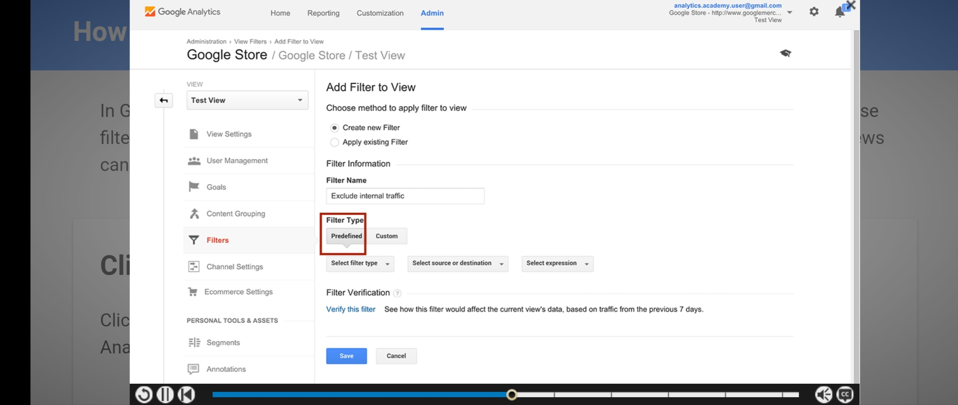

**Coding Challenges Details:**

Today I had received programs from Prof..Venkatesh Bhat(Dept. Of C.S.E). The program was To check the given strings are anagram or not. I solved the program and uploaded it to my GitHub repository

